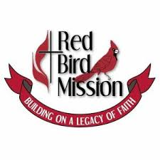
Red Bird Mission Shoebox Project
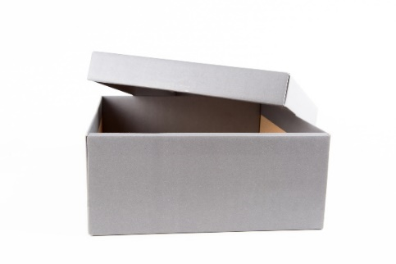
Help to make a difference in someone’s life. One of several Change the World projects during the month of May is to participate in the Red Bird Mission Shoebox Project. Fill a shoebox with personal hygiene items for needy adults and children living in the Appalachian Mountains of Kentucky. Shoeboxes will be available at church before May 1 or feel free to use your own plastic or cardboard shoebox. Lists of needed items are below and are also available at church. Please indicate on the top of the box if this is for an adult male, adult female, male or female child ages 2-4, 5-9 or 10-14. Please seal the box and return to church by May 31. We will see that the boxes are delivered. Thank you for helping us change the world!

Note: All items should be FULL size and in their original containers as purchased. To help items fit in the box, purchase flat bottles of shampoo, hand lotion, etc. and small round cans of shaving cream.

Adult Shoebox
- Comb and/or hairbrush
- Shampoo
- Hand lotion
- Deodorant
- Toothbrush and toothpaste
- Chapstick
- Full size bar of soap
- Washcloth
- Disposable razors
- Shaving cream
- Nail care items
- Socks
- Work gloves or mittens
- Winter stocking hat or scarf
Child’s Shoebox
(Ages 2-4, 5-9, 10-14)
- Comb and/or hairbrush
- Shampoo
- Hand lotion
- Child’s toothbrush and toothpaste
- Chapstick
- Full size bar of soap
- Washcloth
- Socks
- Mittens
- Winter hat
- Small flashlight
- 2-3 small toys
- 2-3 school items
- Christian bookmarks, wristbands and other spiritual items are also appreciated.

The mission is also accepting “gently used” and clean clothing items for men, women, boys and girls. All items must be sent in cardboard boxes. Plastic bags are not accepted.
Thank you for your generosity!

